Role Profile: Volunteer Stock Valuers
Why is this role important?
From time to time, we are lucky to benefit from donations of higher value or collectible items. These can be all kinds of products, from paintings and chinaware to vinyl and books. To help us ensure we continue to value correctly, and to make as much money from these generous donations as we can for NAWT, we are looking to create a small team of knowledgeable volunteers.
How you can support us
- View and research the value of selected products – this will either be at our Watford centre or shop.
- Make recommendations about the best channel to sell through.
- Conduct some off-site visits to companies offering donations of stock.
- The occasional visit to auctions to drop off items.
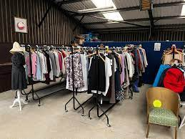
When do we need you?
- Flexible. We have shifts to suit everybody’s needs! Please see our website for availability

Visit www.nawt.org.uk to learn more about us

Ideally, you will….
- Have specialist product knowledge in one category or more
- Have experience of working with antiques dealers or auctions
- Have a passion for researching products and their value
- Be able to donate 1 day or more per month
What you can gain in return?
- An opportunity to engage with and support the local community, making a difference to the lives of animals.
- Enhancing your current skills and experience.
- The chance to join a great team and make new friends along the way.

