Role Profile: Shop Volunteer
Why is this role important?
Our shops are busy and friendly environments at the heart of their communities, and they work closely with their local NAWT Centre. Every day brings new opportunities (and new challenges!), so the role of our shop managers and shop volunteers are varied. Our shops couldn’t operate successfully without our amazing volunteers, and you would be working with the shop manager and as part of a team to create an enjoyable shopping experience for all customers and most importantly to raise as much money as possible for NAWTs work to rescue and rehome animals.
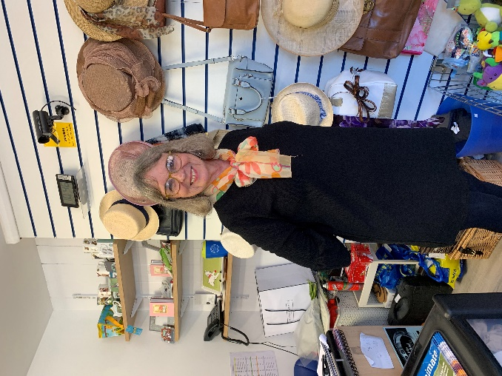What will you gain in return?
How you can support us
- Serving customers and helping to promote the work of the NAWT
- Handling cash transactions
- Keeping the shop clean and tidy
- Sorting and preparing stock ready for sale
- Steaming clothes
- Replenishing stock
- Assisting the Shop Manager to price and rotate stock
- Assisting the Shop Manager to make changes to the shop layout and create exciting window displays
- An opportunity to make a real difference to the future of NAWT
- The chance to learn new skills with training provided
- A chance to use and enhance your current skills and experience
- Meet new people and make friends along the way
Ideally, you will….
- Have good communication skills and enjoy meeting members of the public
- Like to experience new things
- Enjoy working as part of a team
- Have a passion for retail and sales
- Be reliable and have an interest in the work of the trust
When do we need you?
- Flexible. We have shifts to suit everybody’s needs! Please see our website for availability

