Role Profile: Berkshire Events & Fundraising Volunteer
Why is this role important?
As a charity we rely on donated funds to help animals in our care. Our Events & Fundraising volunteers are a vital part of a passionate team to help raise these much-needed funds so we can continue our work.
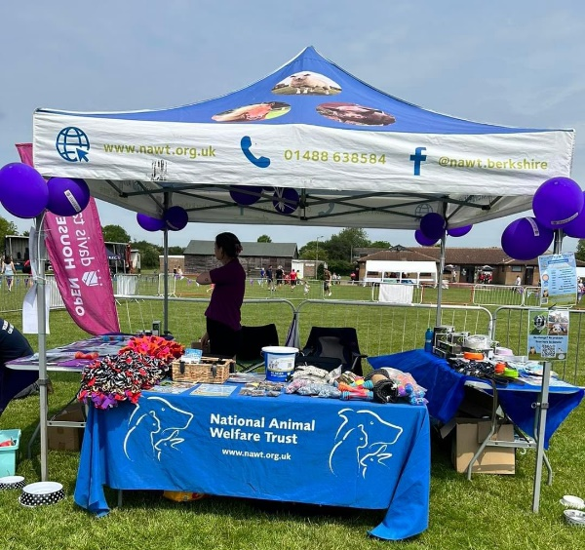
How you can support us
- Travelling to and from events, helping with the setting up/down and management of stalls and/or dog shows.
- Dealing with members of the public and taking payments from sales.
- In-store fundraising, interacting with members of the public through interactive games and information.
- Traffic marshalling or running a stall at onsite events.
- Helping to ensure everybody has a good time, including you!

What will you gain in return?
- An opportunity to enhance the PR and income of your local animal care centre
- Training for your role
- The chance to join a great team
- Tea and coffee provided

Ideally, you will….

- Have a friendly and outgoing personality and enjoy being with the public
- Enjoy event management and love a community get-together
- Have great communication skills
- Enjoy being part of a team
- An interest in the work of the trust.

When do we need you?

Flexible. We have shifts to suit everybody’s needs! Please see our website for availability.

